PHASE 1:- FINAL ASSIGNMENT…

Name:- Kanneti Jaya Pranay.

College:- Jansosn’s Institute Of Technology.

**Create a DB for your college with following parameters:**

1. Create a table for students with name, age, mobile no, registration no., year of batch as columns:-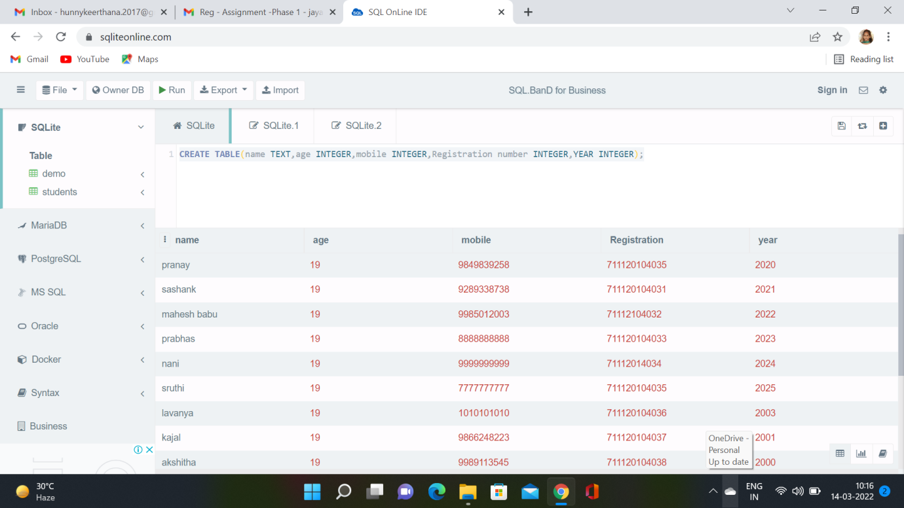

2. Create a table for teachers with name, domain, department as column:-

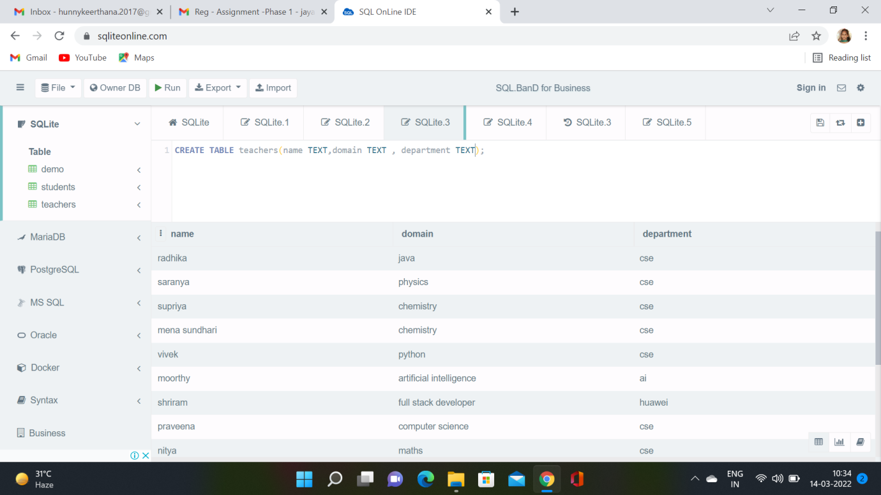

3. Write a query to insert 10 students data and 10 teachers data in the respective table

Students Data:-



Teachers Data:-



4. Write a query to fetch all the students from 2020 batch:-

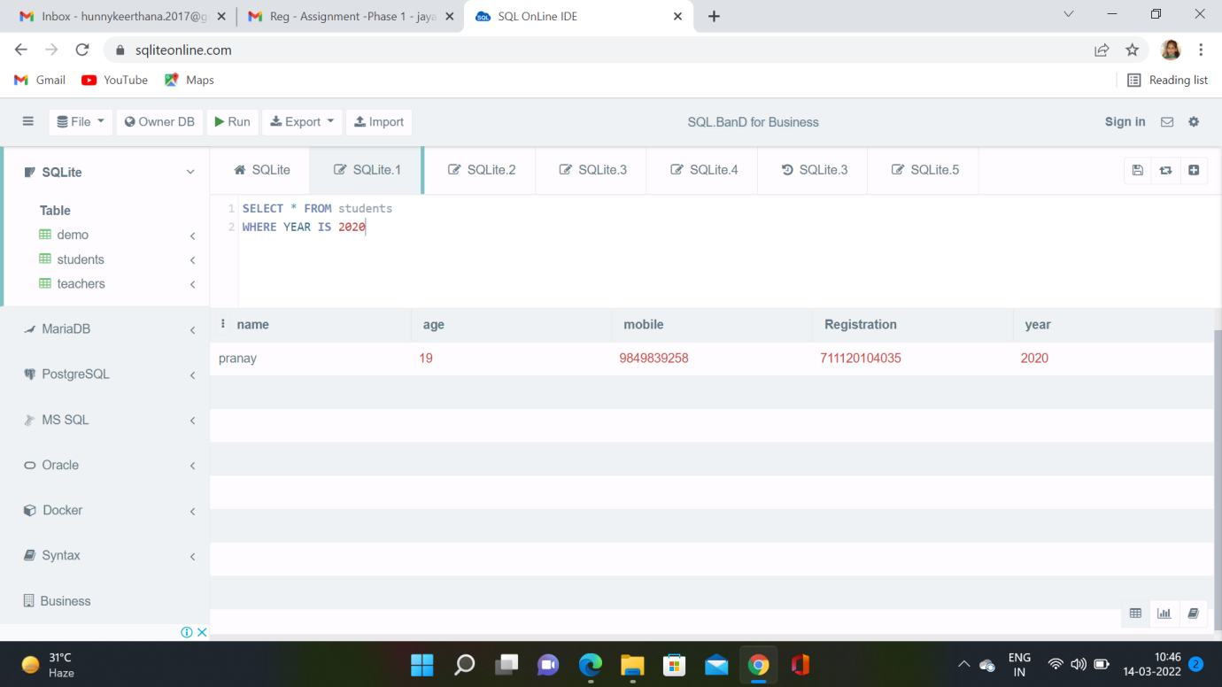

5. Write a query to fetch all teachers from CS department:-

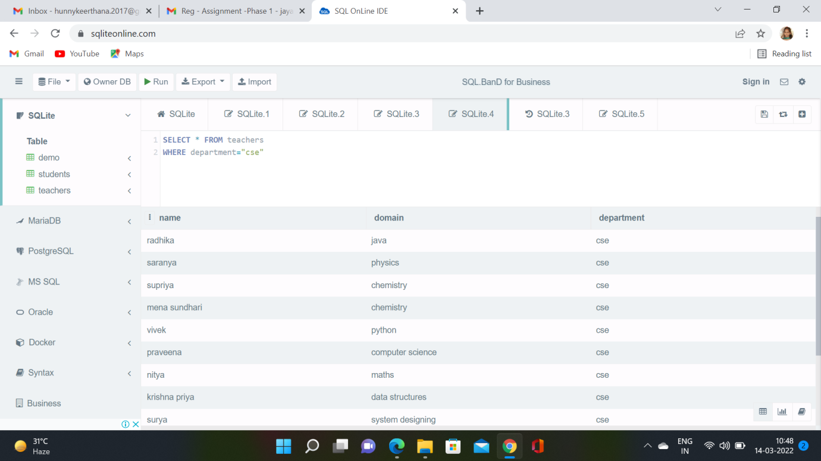

6. Write a query to edit at least 3 records of students:-

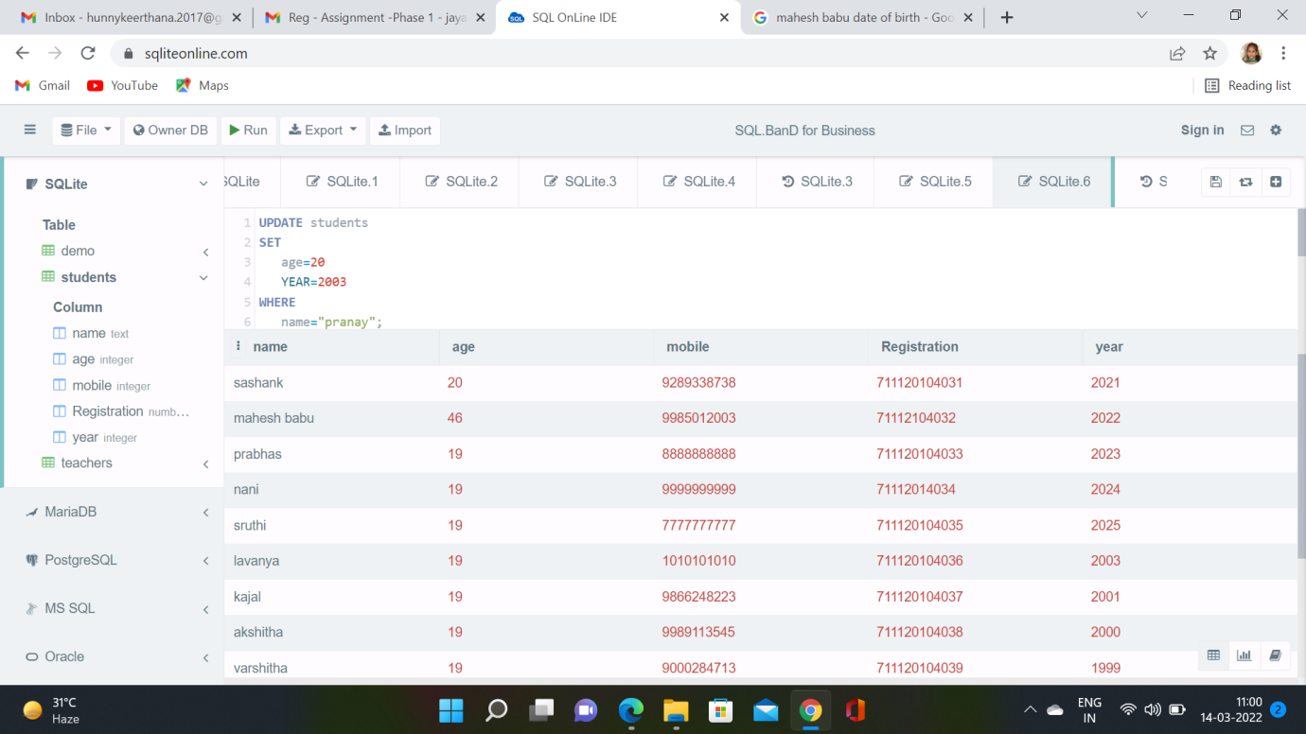

7. Write a query to delete 2 records from teachers table:-

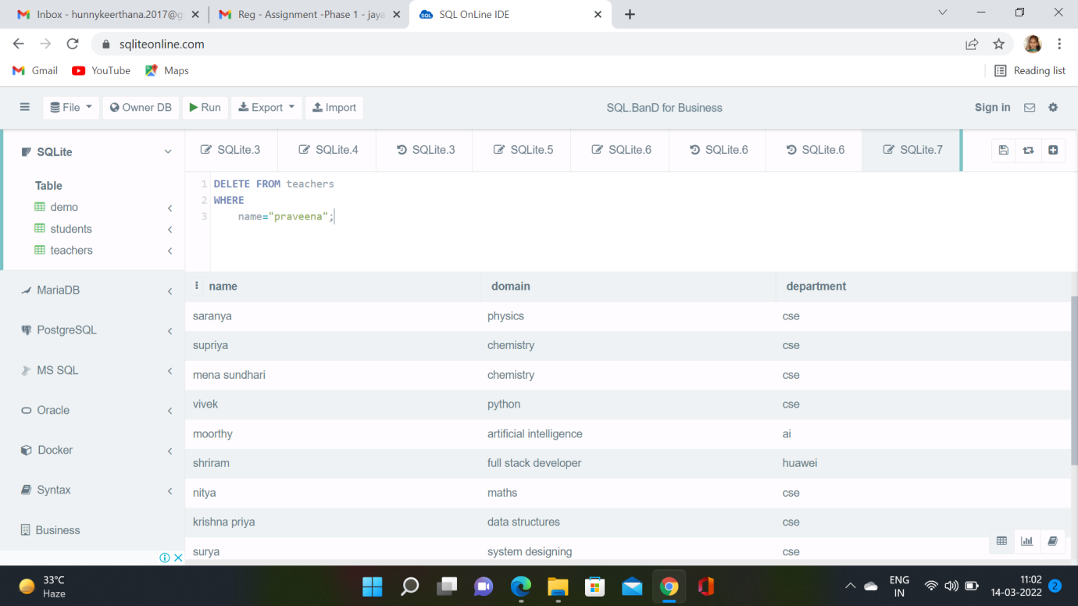

**2) Create an Interest calculator for banks using java which incorporates, Inheritance, polymorphism, classes, object etc…..?**

Solution:-

Here for this problem we are going to use

The packages to solve the problem statement.

package conversion;

public class personal_loan

{

float R,EMI,N,P;

public float loan1(float R1,float N1,float P1)

{

R=R1;

N=N1;

P=P1;

R=(t/12)*100;

EMI=[p*R*(1+R)**N]/[(1+R)**N-1];

return EMI;

}

}

package conversion;

public class home_loan

{

float R,EMI,N,P;

public float loan2(float R1,float N1,float P1)

{

R=R1;

N=N1;

P=P1;

R=(t/12)*100;

EMI=[p*R*(1+R)**N]/[(1+R)**N-1];

return EMI;

}

}

package conversion

public class education_loan

{

float R,EMI,N,P;

public float loan3(float R1,float N1,float P1)

{

R=R1;

N=N1;

P=P1;

R=(t/12)*100;

EMI=[p*R*(1+R)**N]/[(1+R)**N-1];

return EMI;

}

}

package conversion

public class gold_loan

{

float R,EMI,N,P;

public float loan4(float R1,float N1,float P1)

{

R=R1;

N=N1;

P=P1;

R=(t/12)*100;

EMI=[p*R*(1+R)**N]/[(1+R)**N-1];

return EMI;

}

}

import conversion.personal_loan;

import conversion.home_loan;

import conversion.education_loan;

import conversion.gold_loan;

import java.util.*;

class SBI_EMI_CONVERTOR

{

public static void main(String []arg)

{

int choice,ch;

personal_loan p=new personal_loan();

home_loan h=new home_loan();

education_loan e=new education_loan();

gold_loan g=new gold_loan();

System.out.println("1.personal_loan:");

System.out.println("2.home_loan:");

System.out.println("3.education_loan:");

Sysytem.out.println("4.gold_loan:");

scanner s=new scanner(System.in);

do

{

System.out.println("enter the choice:");

choice=s.nextINT();

switch(choice)

{

case 1:

{

System.out.println(p.loan1(EMI));

break;

}

case 2:

{

System.out.println(h.loan2(EMI));

break;

}

case 3:

{

System.out.println(e.loan3(EMI));

break;

}

case 4:

{

System.out.println(g.loan4(EMI));

break;

}

}

System.out.println("press 1 to conitnue 0 to quit");

ch=s.nextINT();

}

while(ch==1);

}

}